User Story-002

Testcase -001 : Verifying the presence of entities

Step1: Navigate to the URL of the opencart site 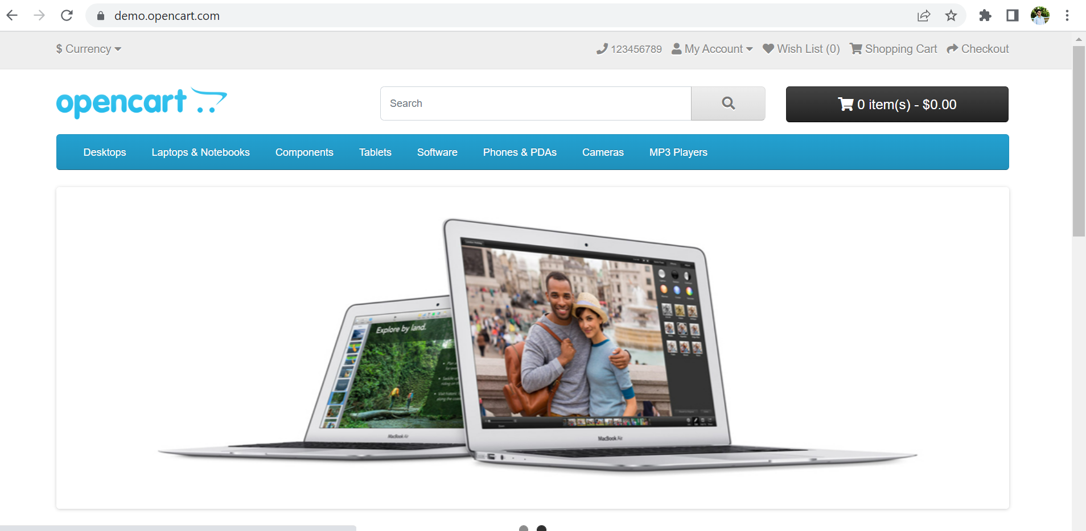

Step2: Search for the entities mentioned

**All the steps are passed and testcase-001 executed successfully.**